


HIGH LEVEL DESIGN (HLD) SIGN-OFF

Authorization Memorandum
This form is to sign-off completion of the Design Phase for CAMPUS MANAGEMENT SOFTWARE AT WORLD SKILL CENTER (WSC).

World Skill Centre (WSC) acknowledges receipt of the deliverables as part of the Design Phase through the submission of this document.

MODULE NAME | Students Management - Counselling and Entrance Examination
MODULE OWNER | Mr. Anil Das

WSC AUTHORITY NAME AND SIGNATURE

SOUL AUTHORITY NAME AND SIGNATURE




High Level Design (HLD)
Of
Counselling And Entrance Exam module
For Implementation of
Campus Management Software
at
World Skill Center (WSC)

Sustainable Outreach And Universal
Leadership (SOUL) Limited

Confidentiality

This document is a strictly confidential communication to and solely for the use of the recipient and may not be reproduced or circulated without SOUL Ltd’s prior written consent. If you are not the intended recipient, you may not disclose or use the information in this documentation in any way

Document Control History

Date | Version No. | Created By | Affected Sections | Reviewed By | Updated By
16-Aug-2023 | 1.0 | Sukalyan | All
31-Aug-2023 | 1.0 |  | All sections | Abhishek Adhikari/ Sharmistha Panda
31-Aug-2023 | 1.1 |  | Document control history, section 1.2, 1.11,2.6.1,2.6.2,3.2.4, |  | Sukalyan
01-Sep-2023 | 1.1 |  | Document control history, section 1.2, 1.11,2.6.1,2.6.2,3.2.4, pre-requisites of all sections | Sharmistha Panda

Project Control

Package Number: | PKG 0111
Project Name: | Campus Management Software At World Skill Center (WSC)
Location: | Bhubaneswar
Customer Name: | World Skill Center (WSC)
Customer Contact Information: | Mancheswar, Bhubaneswar
Project Manager / Email ID: | Sharmistha Panda  sharmistha.panda@soulunileaders.com
Module SME / Email ID: | Mr. Anil Das(anil.das@worldskillcenter.org)
Table Of Contents

HIGH LEVEL DESIGN (HLD) SIGN-OFF 1
Authorization Memorandum 1
Project Control 3
Table Of Contents 4
1 Introduction 6
1.1 Background 6
1.2 Scope and Purpose of the document 6
1.3 Assumptions 7
1.4 Dependencies 7
1.5 Current IT Environment 7
1.6 Document Structure 7
1.7 Required System Architecture 7
1.8 Interoperability Framework 8
1.9 Technical Decision Summary 9
1.10 Architectural Risks & Mitigation 9
1.11 Reference 9
2 Enterprise Architecture Framework (Business Architecture) 10
2.1 Business Drivers 10
2.2 Business Concerns 10
2.3 Business Goals 10
2.4 Business Value Chain 10
2.5 Business Context Diagram 11
2.6 Business Process Flow 11
2.7 Conceptual Architecture 12
3 Architecture Views 12
3.1 Entrance Exam Center Master 12
3.2 Entrance Exam Center Selection 14
3.3 Entrance Exam Select 17
3.4 Counselling Structure 18
3.5 Student Admission 21
3.6 Student Applicant 26
3.7 Exam Center Preference Report Student Applicant 36
3.8 Entrance Exam Declaration 38
3.9 Entrance Exam Centre Allocations 40
3.10 Entrance Exam Admit Card Tool 43
3.11 Entrance Exam Admit Card 45
3.12 Entrance Exam Result Publication 47
3.13 Rank Card Masters 49
3.14 Rank Card Publication Tool 51
3.15 Rank Cards 53
3.16 Reporting Desk 55
4 Tools And Technologies 57
5 Non-Functional Requirements 57
5.1 Performance 57
5.2 Reliability 57
5.3 Usability 57
5.4 Compatibility 57
5.5 Security 57
5.6 Compliance 57
5.7 Documentation 58
5.8 Security: User access and authorization 58
6 Database Design 62
Prototype 63
7 Prototype 64
7.1 Entrance Exam Center Master 64
7.2 Entrance Exam Center Selection 64
7.3 Entrance Exam Select 64
7.4 Counselling Structure 65
7.5 Student Admission 65
7.6 Student Applicant 66
7.7 Entrance Exam Declaration 67
7.8 Entrance Exam Center Allocation 67
7.9 Entrance Exam Admit Card Tool 68
7.10 Entrance Exam Admit Card 68
7.11 Entrance Exam Result Publication 68
7.12 Rank Card Masters 68
7.13 Rank Card Publication Tool 69
7.14 Rank Card 70
7.15 Reporting Desk 70
8 Definitions and Acronyms 70
9 Deployment Description 71

Introduction
The World Skill Center (WSC) is a premier advanced skill training institute established by the Government of Odisha, Skill Development and Technical Education Department, through the Odisha Skill Development Authority (OSDA). The WSC will impart advanced skill training in eight trades from engineering and service sectors. WSC caters primarily to induct the best talent from ITIs and Polytechnics and training them to become globally employable in emerging areas such as "Industry 4.0". WSC is housed in a state-of-the-art, 18-storey, air-conditioned building with nearly half a million square feet of space in the heart of the capital city of Bhubaneswar.

With the implementation of campus management software for WSC the goal is to streamline the operations and functions of the campus by integrating various processes, such as admissions, course registration, academic progress tracking, and financial management, HRMS, Procurement and Inventory management, etc into a unified system. The implementation also aims at providing a user-friendly interface for all stakeholders, making it easier for them to access the necessary information and complete their tasks with ease. The modules to be covered during the implementation of the software include:

Students Management Modules | Infrastructure Management
Academic System | Finance and Accounting System
Procurement & Inventory Management | Training and Placement
Human Resources Management System | Application Integration

Background

The Web Based Campus Management Application at World Skill Centre (WSC) application is required by WSC for the smooth operation of all departments / support functions with on-line delivery of services to all stakeholders.

The project aims to create a mechanism to provide the basis for evolution of an IT enabled state of the art workflow automation system in a planned manner.

Scope and Purpose of the document
The design documents track the necessary information required to effectively define architecture and system design in order to give the development team guidance on the architecture of the system to be developed. Its intended audience is the project manager, project team, and development team. Some portions of this document, such as the user interface (UI), may be shared with the client/user, and other stakeholders whose input/approval into the UI is needed.

This document covers all the functional requirements of the Procurement & Inventory management module, which includes the Buying, Stock and Asset module. The document describes requirements for Items, Suppliers, Warehouses and other master screens which will be used for various transactions throughout the ERP system for Procurement, Stock and Assets.

The scope of Counselling And Entrance Exam

- Entrance Exam Center Data Store
- Student Application and Admission Parameters
- Entrance Exam Declaration
- Entrance Exam Slot Allocations
- Entrance Exam Admit Card Generation
- Entrance Exam Results Data Store
- Rank Card Category Selections
- Rank Card Generation
- Applicant Enrollment

Assumptions

The assumptions are listed as follows:

- The required hardware and software requirements will be provided

- Data loading to be handled by WSC

- All external entities will provide their interface for application integration

Dependencies

The ERP system will be dependant on external interfaces for integration services. The following are a few external interfaces:

- Payment Gateway
- Communication channels such as – Email, SMS, WhatsApp
- Microsoft 365
- Biometric System
- Website

Current IT Environment

Hardware Requirements | Software Requirements
Processor: Intel CPU with at least 8 cores | Operating System: Ubuntu 22.04 LTS
RAM: 16 GB to 32 GB | Web Server: Nginx
Storage: A minimum of 160 GB SSD | Database server: MariaDB
Network: 1 Gbps | Python: 3.10 or later

Document Structure

The following sections are part of this document :

- Business goals, objectives and requirements
- Understand business context and interactions
- Conceptual design
- Overall system context
- Understand use-case and scenarios
- Define implementation

Required System Architecture

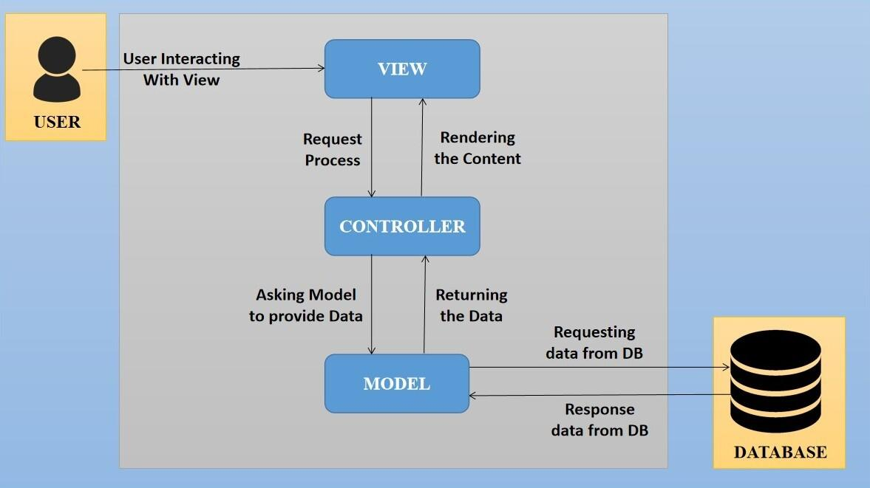

The proposed design is an architectural pattern that separates an application into three main logical
components: The Model, the View and the Controller. Each of these components are built to handle
specific development aspects of the application like:

- The model component corresponds to all the data-related logic that the user works with. This can represent either the data that is being transferred between the View and Controller components or any other business logic-related data

- The View component is used for all the UI logic of the application. It generates a user interface for the user

- The controller is the component that enables the interconnection between the views and the model, so it acts as an intermediary

Interoperability Framework
Frappe is a full stack, batteries-included, web framework written in Python and JavaScript with MariaDB as the database. It is pretty generic and can be used to build database-driven apps with an elegant and consistent UI.

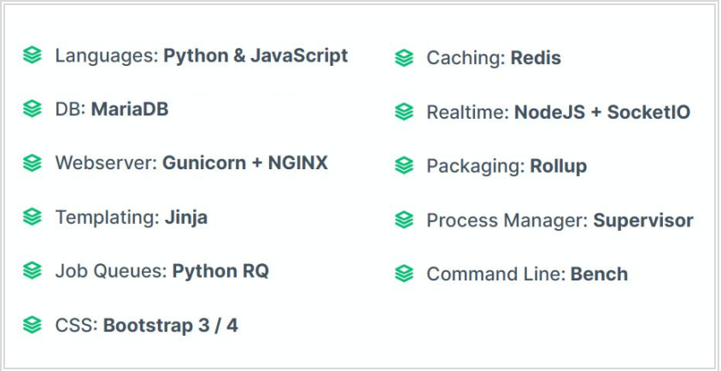

Technical Decision Summary

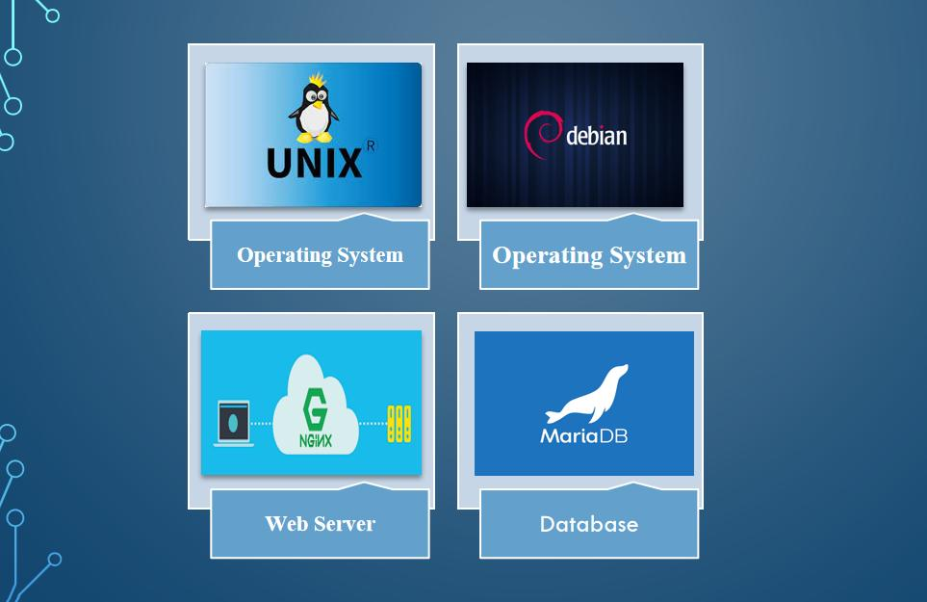

Architectural Risks & Mitigation

Risks | Recommendation
Inability to provide the required hardware resources (Server) for installation of the ERP product | The issue should be brought up during cadence meetings, and the OCAC/WSC IT team should assure timely availability of the required server
Unavailability of API for third party integration | The project timeline schedule needs to be shared with third parties to avoid the delay in integration. Also, inclusion of external teams to meet timelines
The number of users accessing the application exceeds its limit (as specified in the proposal document), leading to performance issues | WSC leadership team to ensure the scalability of the hardware / software resources
End Users of the application unavailable for the training to be provided by SOUL | SOUL to inform WSC Stakeholders on training plan in advance and engage early for training

Reference

Sl No. | Document Name
1 | SRS for Counselling And Entrance Exam

Enterprise Architecture Framework (Business Architecture)

Business Drivers

The following points motivate the business efficacy of Campus Management Software at World Skill Center (WSC) system:

- Integrate the various functions such as Admission, Academics, Examination, Training & Placement, HRMS, Procurement, Finance into a single platform which can be customized as per user requirements

- Implement a common framework for the system and sub systems

- Provide a web based application for the users to interact with the system with role-based access and a consistent look and feel

Business Concerns

Campus Management Software At World Skill Center application is designed to address the following concerns:

Student Management: To help the students / trainers manage the students admission activities, starting from initial communication to course enrollment

Financial Management: Managing finances is a fundamental concern for businesses. This includes budgeting, cash flow management, ledger maintenance, balance sheet,etc

Employee Engagement: Attracting, retaining, and engaging skilled and motivated employees is critical. Human resources concerns also include training, performance management

Procurement management: The source-to-settle process. It encompasses the evaluation, selection, and creation of formal contractual agreements as well as managing the company's ongoing supplier relationships

Business Goals
The goal is to implement a web based Campus Management Application System for efficient internal functioning of the World Skill Center (WSC) with on-line delivery of services to each stakeholder of WSC supported by a suitable, robust, secure and reliable system

Business Value Chain

The ERP system's business value chain typically encompasses the following key components:

Procurement Management: This includes the processes related to sourcing and acquiring raw materials, goods, or services required for the organization's operations. The ERP system streamlines procurement activities, such as supplier management, purchase requisitions, purchase orders, and inventory management, leading to cost savings and better supply chain management.

Production/Operations Management: The ERP system facilitates the planning, scheduling, and execution of production processes. It optimizes resource allocation, tracks work progress, manages bills of materials, and monitors production costs to enhance overall operational efficiency and quality.

Inventory Management: The ERP system enables real-time tracking of inventory levels, stock movements, and stock outs. It helps in maintaining optimal inventory levels, reducing carrying costs, and ensuring timely availability of products.

Financial Management: ERP systems centralize financial data and automate accounting, financial reporting, budgeting, and financial analysis. This streamlines financial processes, enhances accuracy, and provides management with a clear financial overview for better decision-making.

Human Resources Management: ERP systems handle various HR functions, including payroll, employee records, recruitment, performance management, and training. This leads to streamlined HR processes, improved workforce management, and enhanced employee satisfaction.

Business Context Diagram

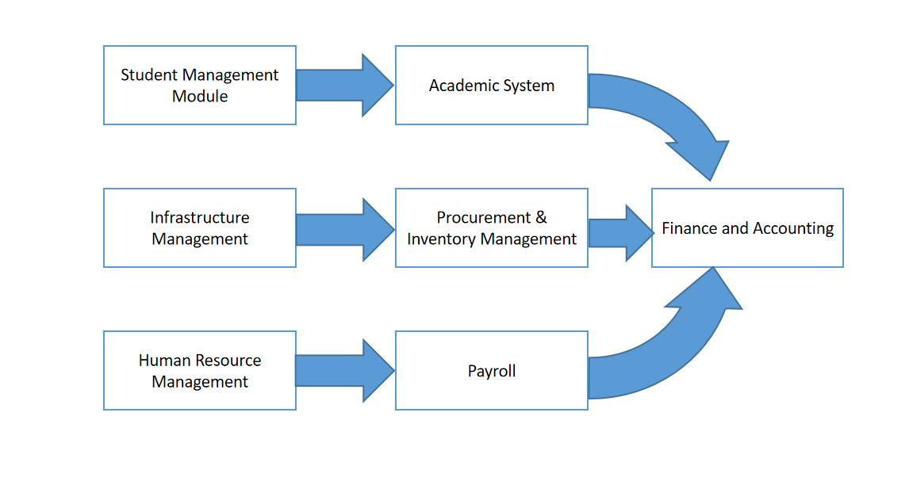

System Context Diagram

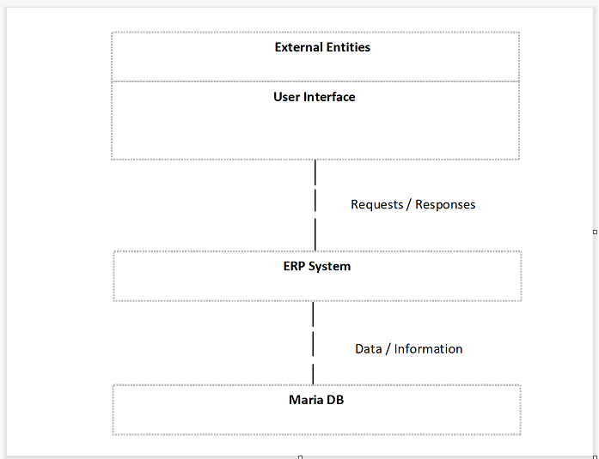

Conceptual Architecture

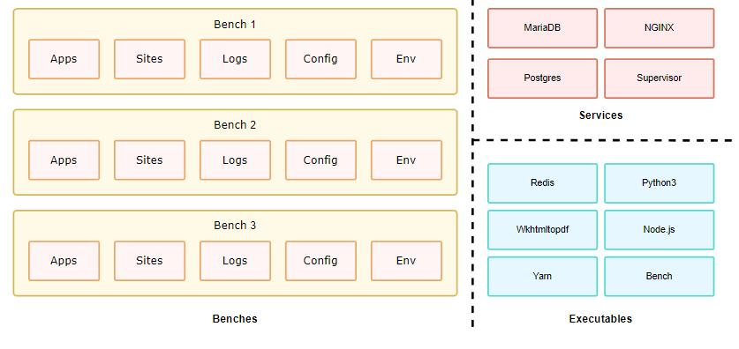

A single bench can host multiple combinations of sites and apps. For the most part, having a single bench works for hosting hundreds of sites that depend on the same versions of said app, given you've scaled up the workers. You can host multiple versions of the application on the same server by creating multiple benches parallelly. The following diagram hints to the system dependencies and how they are used.

Architecture Views

Online Payment

In this form student will do the payment towards the course he/she has enrolled .

Use Case Diagram

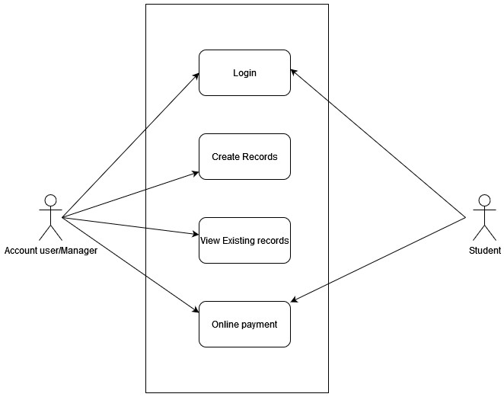
Figure : Online Payment Use case diagram

Design of Workflow

- Not Applicable

Validations

The data entered on this page will undergo a 2 step validation (I.e. client side and server side validation).

Client Side Validation
Client-side validation refers to the process of validating user input directly on the client's web browser before saving it to the server for further processing. Following are some client side validations done for Item screen.

The following validations are done on client side for Online payment:
- Page/Screen should saved first before going for payment.Then Payment button will visible.

Server Side Validation:

- Order no. Should be unique so we have added validation to make the order no. Unique.

Field List:
ID | Field Name | Field Type | Validation/Action | Mandatory | Remarks | R= Rename
 |  |  |  |  |  | N= New
 |  |  |  |  |  | D= Delete
1 | Transaction Progress | Data
2 | Payment Order Status | Select
3 | Posting Date | Date |  | 1
4 | Company | Link |  | 1
5 | Mode of Payment | Data |  | 1
6 | Payment From / To | Section Break
7 | Party Type | Link |  | 1
8 | Party | Link |  | 1
9 | Roll No | Data
10 | Student Email | Data
11 | Party Name | Data
12 | Permanent Registration Number | Data
13 | Total Outstanding Amout | Currency
14 | Paying Amount | Currency |  | 1
15 | Transaction ID | Data
16 | Transaction Status | Data
17 | Transaction Status Description | Long Text
18 | Date Time of Transaction | Datetime
19 | Payment Status | Check
20 | Payment id | Data
21 | Remarks | Text
22 | Gateway Name | Data
23 | Declaration | Small Text

Processes After Form Submission
Email will be sent to the student for the online transaction.

Pre-requisites and Dependency
- Student
- Fees amount to be paid

Design of Workflow

Design of Workflow

- Not Applicable

Validations

Client Side Validation:

Client-side validation refers to the process of validating user input directly on the client's web browser before saving it to the server for further processing. Following are some client side validations done for Item screen.

The following validation is done on client side:
- Mandatory checks for fields : Party

Server Side Validation:

Server-side validation refers to the process of validating user input on the server to ensure data integrity, security, and adherence to business rules before accepting or processing the information.
The following validations are done on server side for Entrance exam center selection Screen:
- Check if the page is saved with required input data.

Notification:

- Email notification will be sent once payment is done.

Design of Workflow

- Not Applicable

Database Design

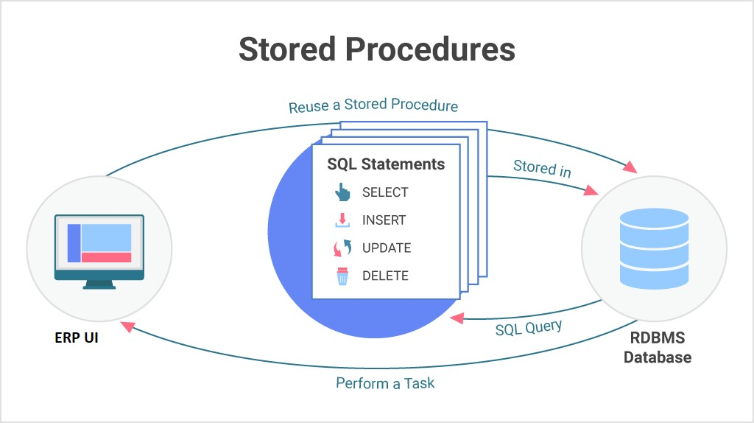

Prototype

Prototype
The screen samples that have been derived based on the requirements gathered from the users / SME’s of the Project Plan Monitoring module

Online Payment
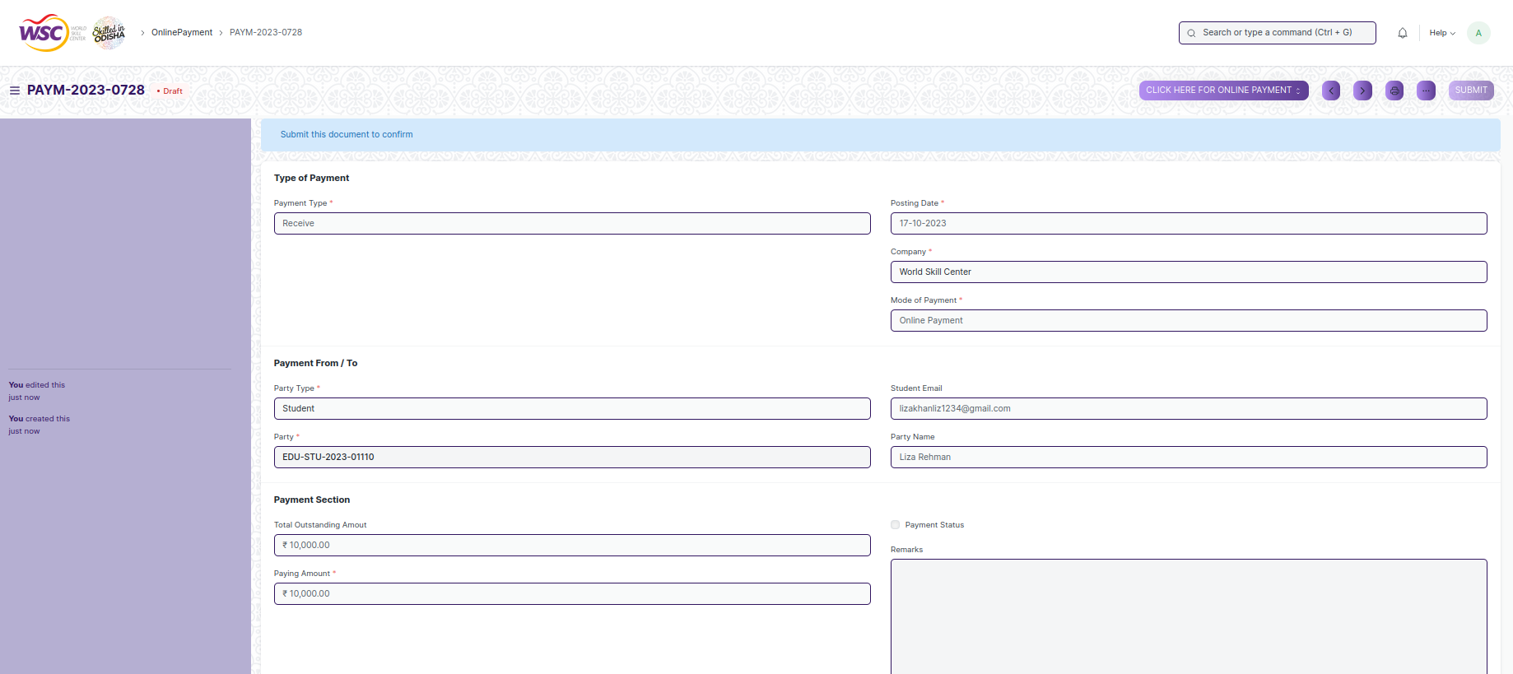

Figure : Online Payment

Payment gateway page
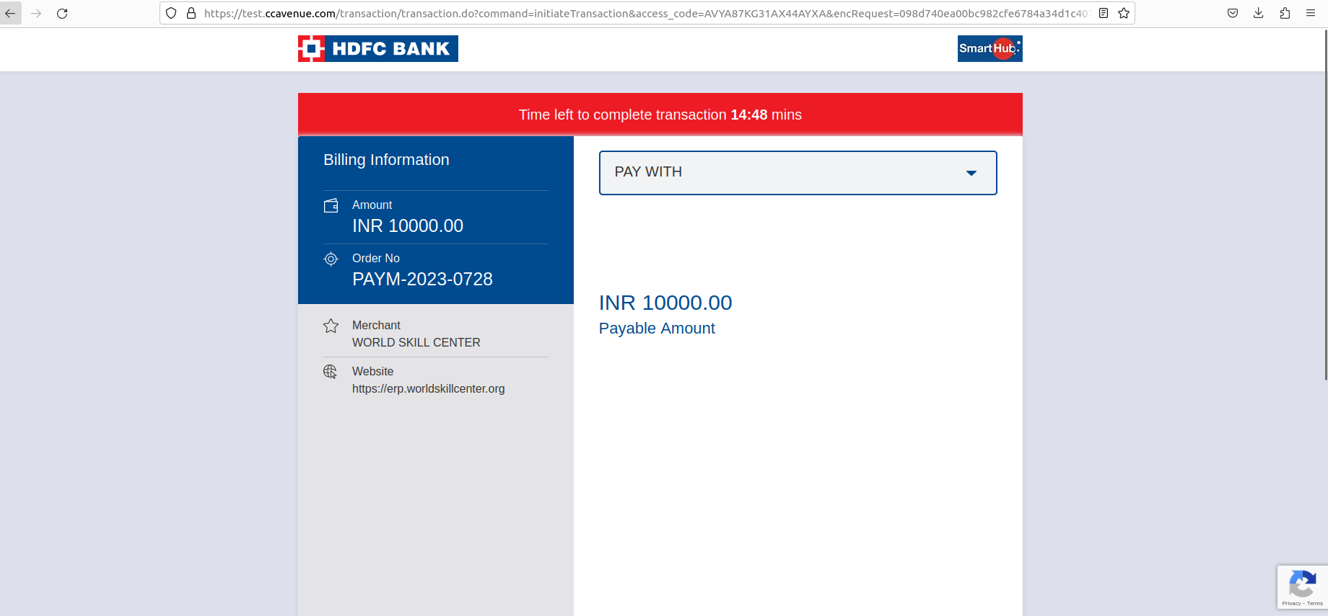

Figure : Payment gateway

Online Payment with Response
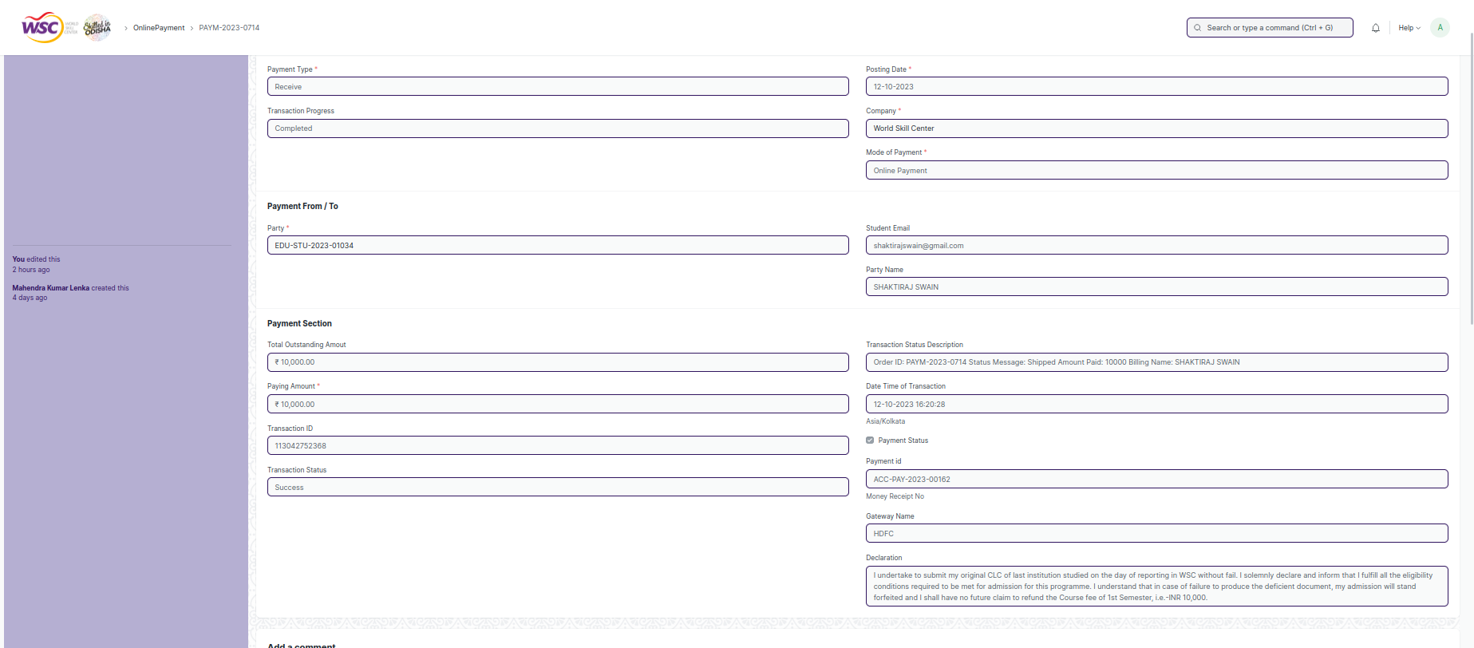

Figure : Page updated with bank Response

Definitions and Acronyms

The following table explains the terms and abbreviations used in the document:

Abbreviation | Description
HLD | High Level Design
LLD | Low Level Design
API | Application Programming interface
NA | Not Applicable
ERP | Enterprise Resource Planning
HRMS | Human Resource Management System
GDPR | General Data Protection Regulation
PCI DSS | Payment Card Industry Data Security Standard

Deployment Description

- Application Name: Campus Management Application At World Skill Center (WSC)

- Deployment Environment: Production

- Server Information: IP address:117.250.67.19, domain name:erp.worldskillcenter.org, hosting provider: OCAC

- Deployment Date: 13-06-2023

- Database Information: MariaDB 10.6.*, Installed on the same server as the Application

